IntelliMeet Pro: AI Meeting Assistant & Workflow Management
FYP– I REPORT
BS(SE) Fall 2025
Name: Mustafa Masood (22k-4818)
Name: Laiba Fatima (22k-5195)

Supervisor: Ms. Rubab Jaffar

Department of Computer Science
FAST-National University of Computer & Emerging Sciences, Karachi

- Introduction
Meetings are essential components of organizational communication, yet they remain one of the most inefficient and error-prone processes within modern enterprises. As remote and hybrid work environments have expanded, organizations rely heavily on digital platforms such as Zoom, Google Meet, and Microsoft Teams, producing massive amounts of conversational data. However, traditional note-taking approaches fail to capture this data reliably, resulting in missed action items, unclear decisions, and poor follow-up.
IntelliMeet Pro addresses these challenges by implementing an AI-powered meeting assistant and workflow management platform capable of autonomous meeting participation, transcription, semantic summarization, and direct project-management integration. The system leverages advanced NLP, speaker diarization, vector-based semantic search, and workflow automation, providing organizations with a persistent, structured, and intelligent knowledge layer for their meetings.
The project’s objectives are speech processing, semantic retrieval, meeting summarization, and AI-assisted collaboration workflows. Using a layered architectural approach and Waterfall methodology, IntelliMeet Pro establishes a robust foundation for the subsequent development phases in FYP-II.
This report presents the project’s methodology, system architecture, diagrams, testing strategy, results obtained in FYP-I, and next-phase goals.
- Methodology
  - Overview of Development Approach
The development of IntelliMeet Pro follows the Waterfall Development Model, ensuring a structured, sequential progression through distinct phases. This methodology was selected due to the project's well-defined requirements, need for comprehensive documentation, and emphasis on stability over rapid iteration. Each phase must be completed and formally reviewed before advancing to the next, minimizing ambiguity and ensuring clear deliverables at every stage.
The Waterfall model provides a linear roadmap covering requirements gathering, design, implementation, testing, deployment, and maintenance, with each stage producing formal deliverables that guide subsequent phases.
The phases undertaken in FYP-I include:
- Requirements Analysis
  - Conducted stakeholder meetings with academic supervisor
  - Performed comprehensive literature review of existing meeting management solutions
  - Analyzed competing products to identify feature gaps
  - Developed detailed Software Requirements Specification (SRS) document
Deliverables:
  - Project proposal document
  - Feasibility study report
  - Approved Software Requirements Specification
  - Initial technology stack selection
- System Design
  - Designed layered system architecture separating presentation, application, data, and integration layers
  - Created comprehensive database schema with Entity-Relationship Diagrams (ERD)
  - Designed user interface wireframes and prototypes using Figma
  - Documented Software Design Specification (SDS)
Deliverables:
  - Approved Software Design Specification
  - Database schema and ERD diagrams
  - System architecture diagrams
  - UI/UX wireframes and mockups
  - API documentation templates
- Planning & Implementation Strategy
  - Definition of modules, resource allocation, tool selection, and technology stack validation.
Current Status (FYP-I Completion): As of December 2025, the following core modules have been successfully implemented and tested:
  - Speech-to-text transcription using Whisper API
  - Speaker diarization and identification
  - AI-powered summarization using GPT-4
  - Action item extraction with assignee attribution
  - Key takeaways generation
These deliverables form the foundation for implementation activities planned for FYP-II.

  - System Architecture (Layered Architecture Model)
IntelliMeet Pro adopts a 4-layered architecture, ensuring modularity, scalability, and maintainability.
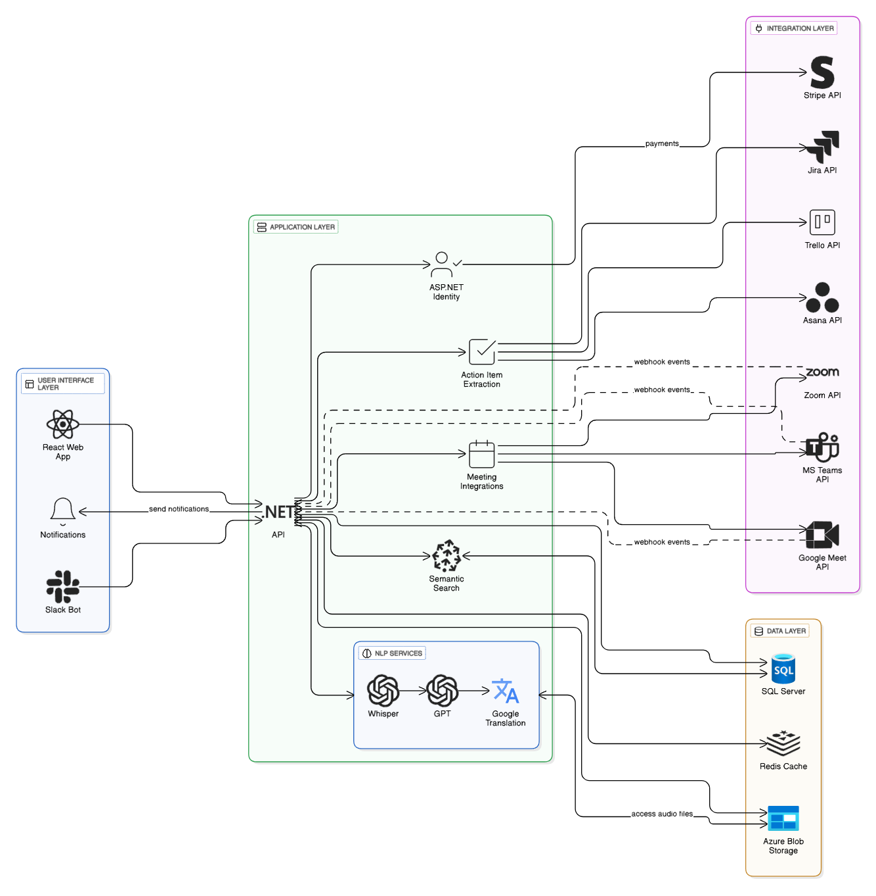
Figure 1. Architecture Diagram
- Presentation Layer (Frontend UI/UX)
  - Built using React, TypeScript, TailwindCSS 4, and Shadcn UI.
  - Handles user interactions, dashboards, search interfaces, transcript and summary displays.
  - Provides responsive and accessible design.
- Application Layer (Business Logic)
  - Developed using ASP.NET Core 8.0.
  - Contains workflows for transcription, summarization, diarization, semantic search orchestration, workspace logic, and integration routing.
  - Manages Slack bot processing, meeting scheduling, and workflow automation.
- Data Layer (Persistence & Storage)
  - SQL Server for structured data (users, workspaces, transcripts, summaries, action items).
  - Azure Blob Storage for meeting audio files.
  - Pinecone Vector DB for semantic embeddings and retrieval.
  - Ensures data consistency, confidentiality, and integrity.
- Integration Layer (External Services/APIs): Handles all third-party interactions:
  - OpenAI Whisper (transcription)
  - OpenAI GPT-4 (summaries)
  - Jira, Trello, Asana (task synchronization)
  - Slack Bot via Bolt Framework
  - Stripe for subscriptions
  - Google Translation API for bilingual transcript support
  - Zoom / Google Meet / MS Teams APIs for bot deployment
This layer isolates external dependencies, enabling modifications without affecting core logic.
  - Use Case Diagram
The system supports over 12 major functional domains. The key actors include:
- New User
- Registered User
- Team Lead
- Workspace Admin
- Meeting Participant
- System
- External Services (APIs, Slack, PM Tools)

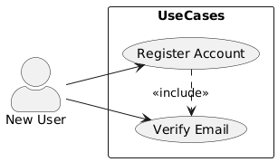
Figure 2. New User Use Case Diagram
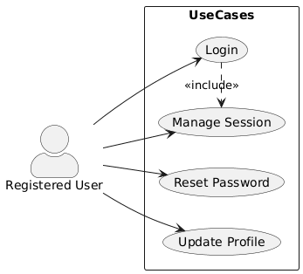
Figure 3. Registered User Use Case Diagram
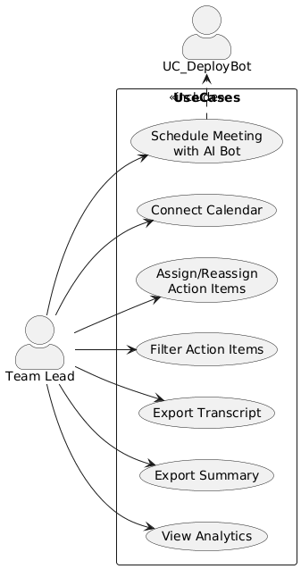
Figure 4. Team Lead Use Case Diagram
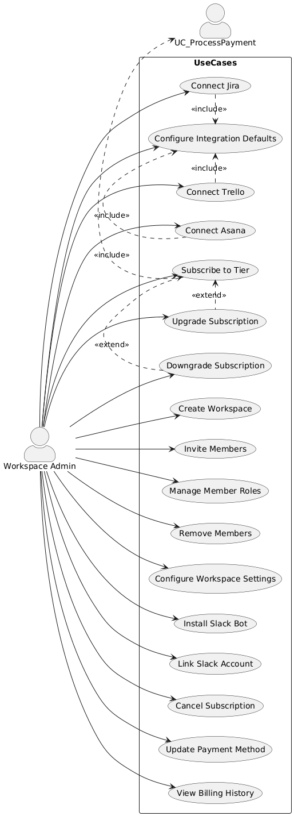
Figure 5. Workspace Admin Use Case Diagram
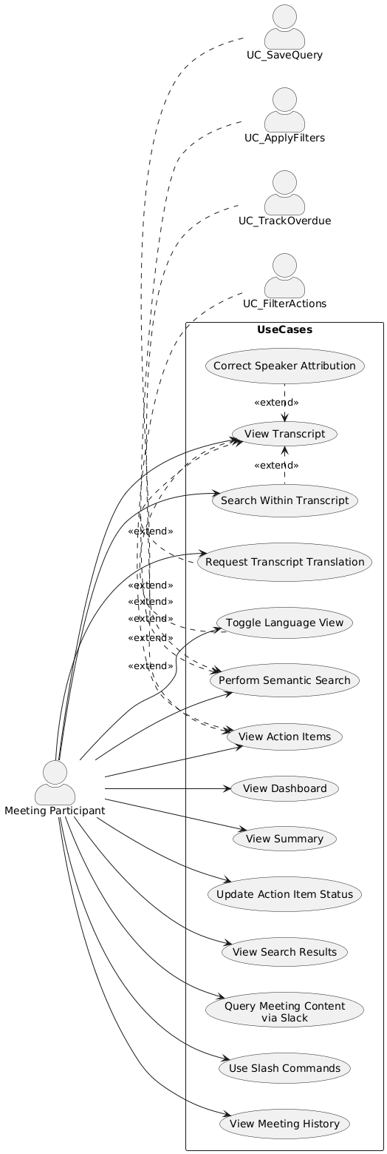
Figure 6. Meeting Participant Use Case Diagram
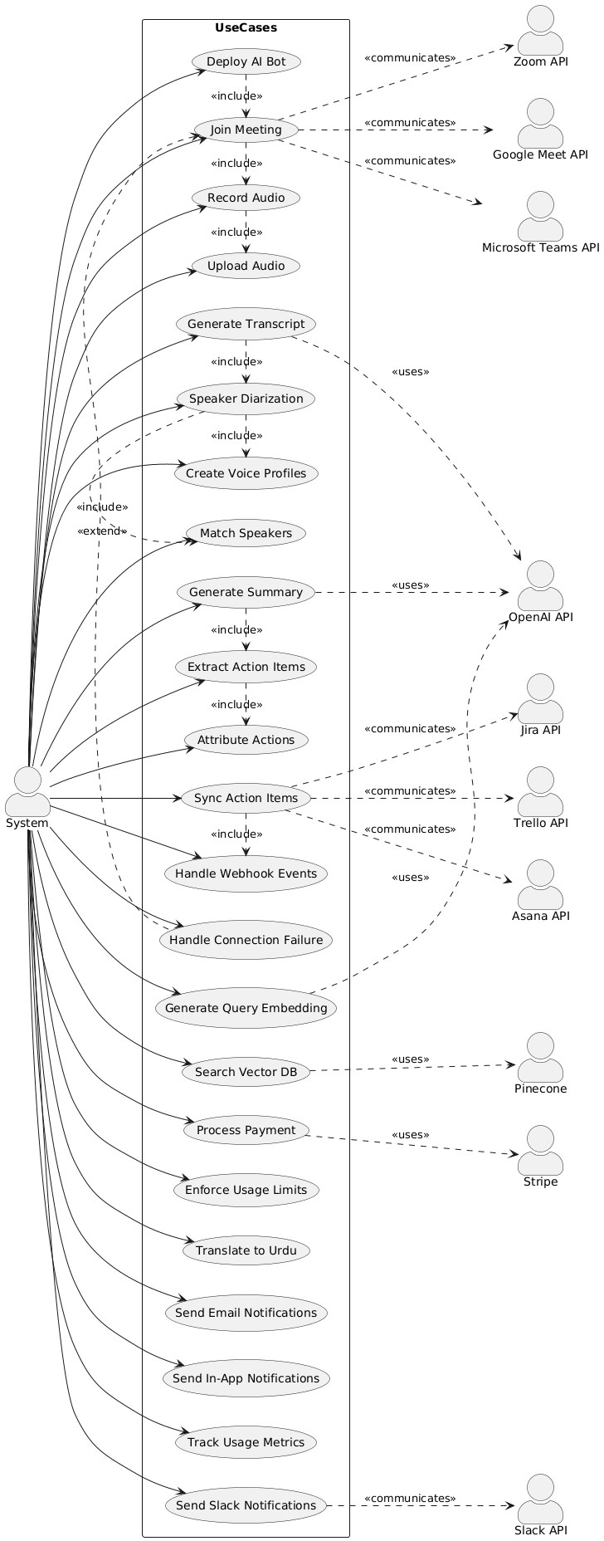
Figure 7. System Use Case Diagram
Key use cases:
- User registration, login, workspace creation
- Meeting scheduling and AI bot deployment
- Transcription and diarization
- AI summarization and action item extraction
- Semantic search across historical meetings
- Integration with project management tools
- Slack bot conversational assistance
- Subscription and billing operations
- Testing and Results
During FYP-I, the primary objective was to validate the technical feasibility of IntelliMeet Pro’s core AI components before proceeding to full-scale implementation in FYP-II.
The following subsections summarize the results obtained from early testing of the Transcription, Speaker Diarization, Summary Generation, Action Item Extraction, and Key Takeaway Identification modules using the OpenAI Whisper and GPT models.
  - Transcription Testing (OpenAI Whisper API)
To validate whether Whisper API provides sufficiently accurate, reliable, and consistent speech-to-text transcription to meet IntelliMeet Pro’s requirements of 90%+ transcription accuracy for English-language meetings.
Audio Scenario | Accuracy Achieved | Observations
High-quality mic | 94–96% | Very minor omissions; punctuation generally correct
Laptop mic | 91–93% | Slight difficulty with overlapping speech
Background noise | 88–91% | Noise influences accuracy but still acceptable
  - Speaker Diarization Feasibility Testing
To validate the feasibility of separating speakers and generating metadata for persistent speaker identification in multi-speaker meetings.
- Whisper’s built-in segmentation could differentiate speakers reasonably when audio channels were distinct and turn-taking was clean.
- Accuracy based on short audio clips: 70–80% correct speaker segmentation.
- A hybrid diarization approach—Whisper + custom embedding matching—will be required for consistent, persistent speaker profiles across meetings.
- The results are sufficient to proceed confidently with full diarization development in FYP-II.
  - Summary Generation Testing (OpenAI GPT Models)
To evaluate whether GPT-4 can produce structured, clear, and contextually accurate summaries of meeting transcripts.
Input: Sample transcripts generated using Whisper.
Criteria | Outcome
Relevance | High, captures all major themes
Structure | Excellent, consistently forms clean sections
Conciseness | Appropriate, avoids redundant text
Faithfulness | 90–95% accurate to transcript content
  - Action Item Extraction Testing (OpenAI GPT)
To confirm the ability of GPT models to identify actionable items, assign responsibilities, and discern deadlines/next steps from the content of a meeting transcript.
Metric | Observed Performance
Task identification accuracy | 85–92%
Correct assignee detection | 80–88%
Priority/due date extraction | Accurate only when explicitly mentioned
  - Key Takeaways Extraction Testing (OpenAI GPT)
To determine GPT’s ability to extract concise, meaningful takeaway points helpful for quick meeting recap.
- GPT consistently produced clear, high-level takeaways.
- Works strongly as an add-on to summary and action-item modules.

- System Diagram

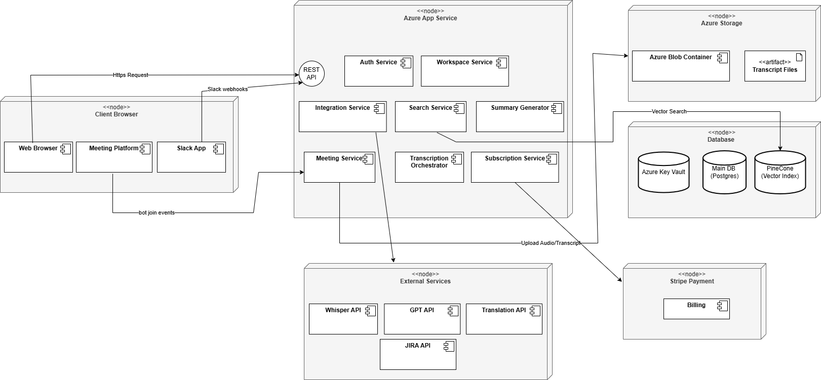
Figure 8. Deployment Diagram
This deployment diagram shows IntelliMeet Pro running through a client browser that communicates with a central Azure App Service hosting all backend services, including authentication, meetings, integrations, search, transcription orchestration, summarization, and subscriptions. The backend connects to Azure Storage for transcript files, a database cluster containing the main Postgres DB, Key Vault, and Pinecone vector index, and various external APIs such as Whisper, GPT, Translation services, Jira, and conferencing platforms. Stripe Payment handles billing and subscription processing, completing the system's external integrations.
Backend orchestrates workflows and interacts with:
- SQL Server (structured data)
- Azure Blob Storage (audio)
- Pinecone (embeddings)
- OpenAI APIs (transcripts, summaries)
- Jira/Trello/Asana (task sync)
- Stripe (billing)
- Zoom/Meet/Teams (bot deployment)
- Goals For FYP-II
FYP-II focuses on full implementation, integration, testing, and deployment.
The key goals include:
  - Backend Implementation
- Develop complete ASP.NET Core 8.0 API
- Implement semantic search pipeline with Pinecone
- Integrate Jira, Trello, Asana synchronizations
- Develop Slack bot capabilities
- Implement secure subscription system via Stripe
- Build role-based workspace management
  - Testing & QA
- Conduct unit, integration, system, and performance testing
- Test AI pipeline latency and accuracy
- Validate cross-platform bot deployment reliability
- Check subscription limits and access controls
- Conduct UAT with real users
  - Deployment
- Deploy backend to Azure App Services
- Deploy database to Azure SQL
- Set up Azure Blob Storage for audio
- Deploy frontend to Vercel/Azure Static Web Apps
- Perform production-level testing under realistic conditions
  - Final Deliverables
- Fully functioning IntelliMeet Pro platform
- Technical manual and user documentation
- Final thesis/report
- FYP-II presentation and open house demonstration
- Conclusion
IntelliMeet Pro addresses a critical need in modern organizational environments by transforming raw meeting discussions into structured, actionable, and persistent knowledge assets. Through detailed requirement analysis, architectural modeling, feasibility validation, and prototype-level testing, FYP-I successfully establishes the technical foundation for a robust, scalable, and enterprise-ready system.
The comprehensive SRS, architecture blueprint, and system models developed in this phase ensure that FYP-II can proceed with clarity, precision, and technical confidence. With AI-driven transcription, summarization, semantic search, and workflow automation, IntelliMeet Pro has the potential to redefine meeting productivity across modern organizations.
The next phase of FYP-II will focus on implementing the fully functional system, validating its performance, and deploying it on cloud infrastructure to deliver a production-ready solution.
- References
- Sumit Asthana, Sagih Hilleli, Pengcheng He, and Aaron Halfaker, "Summaries, Highlights, and Action Items: Design, Implementation and Evaluation of an LLM-powered Meeting Recap System," Proceedings of the ACM on Human-Computer Interaction, vol. 7, no. CSCW1, pp. 1-29, April 2023. https://doi.org/10.1145/3711074
- Xinyue Chen, Shuo Li, Shipeng Liu, Robin Fowler, and Xu Wang, "MeetScript: Designing Transcript-based Interactions to Support Active Participation in Group Video Meetings," Proceedings of the ACM on Human-Computer Interaction, vol. 7, no. CSCW2, pp. 1-32, 2023. https://doi.org/10.1145/3610196
- Yun Hu, Wenhui Shi, Zhen Feng, and Danqi Ji, "MeetingBank: A Benchmark Dataset for Meeting Summarization," arXiv preprint, 2023. https://arxiv.org/abs/2305.17529
- OpenAI, "Whisper API Documentation - Speech to Text," OpenAI Platform Documentation, 2024. Available: https://platform.openai.com/docs/guides/speech-to-text
- OpenAI, "GPT-4 API Documentation," OpenAI Platform Documentation, 2024. Available: https://platform.openai.com/docs/guides/gpt
- Pinecone Systems, "Pinecone Vector Database Documentation," 2024. Available: https://docs.pinecone.io/
- Zoom Video Communications, "Zoom API Documentation," Zoom Marketplace, 2024. Available: https://marketplace.zoom.us/docs/api-reference/
- Microsoft Corporation, "Microsoft Graph API Documentation - Teams," Microsoft Learn, 2024. Available: https://learn.microsoft.com/en-us/graph/api/resources/teams-api-overview
- Google LLC, "Google Meet API Documentation," Google Developers, 2024. Available: https://developers.google.com/meet
- Slack Technologies, "Slack Bolt Framework Documentation for JavaScript," Slack API Documentation, 2024. Available: https://slack.dev/bolt-js/
- Slack Technologies, "Slack API Reference," Slack API Documentation, 2024. Available: https://api.slack.com/
- Atlassian, "Jira Cloud REST API Documentation - Version 3," Atlassian Developer Documentation, 2024. Available: https://developer.atlassian.com/cloud/jira/platform/rest/v3/
- Trello, "Trello REST API Documentation," Atlassian Developer Documentation, 2024. Available: https://developer.atlassian.com/cloud/trello/rest/
- Asana, "Asana API Documentation - Version 1.0," Asana Developers, 2024. Available: https://developers.asana.com/docs
- Stripe, Inc., "Stripe API Documentation - Version 2023-10-16," Stripe Documentation, 2024. Available: https://stripe.com/docs/api
- Google LLC, "Google Cloud Translation API Documentation - Version 3," Google Cloud Documentation, 2024. Available: https://cloud.google.com/translate/docs

